WELCOME TO 4-H:
A New Family’s Guide


WELCOME TO 4-H…

Did you know that 4-H members and leaders live all over Kansas, in all 50 United States, and in 82 other countries around the world! 4-H members are 7-19 years old, and live in cities, towns, and farms. There are over 22,000 4-H members in community clubs across Kansas!

4-H is youth having fun and learning with their friends…welcome to the Kansas 4-H Program. We understand that you may have many questions your first few years in the program and this guide will be there to help! Also know that you can always call your 4-H community club leader or the Extension Agent for questions that arise.

The basic philosophy of 4-H is to strengthen the mental, physical, moral, and social development of boys and girls, thereby, helping develop desirable citizens and leaders. The main objective is the development of boys and girls through participation in projects, events, and other various activities. 4-H is intended to supplement, not replace, the three primary educational institutions…namely school, church, and home.

EMBLEM, COLORS, PLEDGE, & MOTTO:

The four-leaf clover is the official 4-H emblem. The four “H’s” stand for head, heart, hands, and health. In Spanish-speaking countries where 4-H programs have been established, the organization is known as ‘4-S’, where each letter stands for ‘Salud, ‘Saber, Sentir’ and ‘Servir.’

The colors of 4-H are:
Green- life, springtime, youth
White- fresh, clean

The 4-H pledge is:
I PLEDGE
My Head to clearing thinking,
My Heart to greater loyalty,
My Hands to larger service,
My Health to better living,
For my club, my community, my country, and my world.

The 4-H motto is: “To Make the Best Better!”

4-H members and volunteers should learn the pledge and try to follow it in their daily life. The motto is to remind us to always strive for improvement, to continually set goals and give every effort your best.
HOW DID 4-H BEGIN?

4-H began in the early 1900’s. The first groups were call Boys and Girls clubs. Girls participated in canning clubs, and boys participated in corn and pig clubs. In 1914, Congress passed an act that established Cooperative Extension and 4-H across the country. There were corn, poultry and garden clubs as early as 1905 in Kansas. The first county agents were hired about 1915 and the first State 4-H Program Leader was hired in 1916.

4-H has certainly changed since its early days! 4-H is no longer a program strictly for rural kids! While we embrace our rich history, 4-H has evolved to meet the needs of today’s youth. With learning experiences designed to develop boys and girls of all ages, there is something for everyone!

4-H MEMBERSHIP & PROGRAMS

Youth wanting to join must be 7 years old and not have passed their 19th birthday by January 1 of the current year in order to be eligible for 4-H. Members live in towns, in the country, and on farms. 4-H is open to all youth regardless of race, color, national origin, sex, sexual orientation, or disability.
The 4-H year runs from October 1 thru September 30.

Kinds of 4-H programs available are:
- 4-H Community Clubs: A group of youth organized with officers, appropriate to the group, and with one or more leaders under the sponsorship of K-State Research and Extension. Most clubs hold monthly meetings, normally the same night of the week each month. Clubs have a planned program at each meeting. Club activities can include demonstrations, project work, community service, and social events.
- 4-H Cloverbuds: A group of 5-6 year olds who learn cooperatively and are activity focused. Some 4-H Cloverbuds may meet monthly where they complete activities that are developmentally and age appropriate.
- SPIN Clubs: Combine the concept of Special Interest Groups with the 4-H Club model to provide short-term positive youth development experiences.
- School Enrichment: A learning experience presented or coordinated by Extension personnel with school officials as part of your school classroom activities.

WHO HELPS IN 4-H?

4-H is really a family program. Your parents and family are important in 4-H. They help you with project work and other activities.

4-H members are also helped by volunteer leaders. Every 4-H club needs one or more adult leaders. These leaders teach youth, organize the club, help officers, assist at meetings, and orient new parents about 4-H.

There are various kinds of leaders in 4-H:
- Community Club Leaders: responsible for the general organization of the club
- Project Leader: helps members with their project work
- Jr. Leaders: 4-H teens who work with an adult leader to give leadership to activities, events, and/or projects
- Parents: parents are important in 4-H! They show interest and concern for their children by attending meetings, serving as leaders, helping in club activities, and serving on committees.

All registered volunteers go through the Volunteer Screening process. To be adult leaders, you must apply, go through a screening process, and attend an orientation training. This process ensures the protection of both the 4-H members and adult volunteer.

WHAT DO YOU DO IN 4-H?

In 4-H, youth “learn by doing.” Youth learn useful skills, how to get along with people, and how to help your community and country. Here are some of the activities you can take part in:

Project Work… members choose at least one project of interest per year
Demonstrations… members learn to speak in front of others
Recreation… members play games and make new friends
Community Service… members help improve their community
County Contests… members may choose to enter contests and compete
Exhibits… members exhibit their best project work at the county fair
Camps… members may participate in a day camp, overnight camp, or stay in the dorms on the K-State campus
Exchanges… members can learn about the life of a 4-H across the state and across the country

CLUB MEETINGS

4-H members are given the opportunity to learn and practice decision-making in group situations. 4-H members are expected to attend their club’s meetings, and parents are encouraged to attend as well…4-H is a family affair!
In 4-H, there are two kinds of meetings:
- Club meetings: Members plan and carry out what they want to do as a group. A good club meeting has four parts with definite activities in each part.
  - Opening- Call to order, Pledge of Allegiance, and 4-H Pledge
  - Business- Roll call, secretary’s report, treasurer’s report, committee reports, old business, and new business
  - Education- program, demonstrations, talks, and guest speakers
  - Fun- recreation, songs, skits, refreshments, and entertainment
- Project Meetings: Members get together to work on their projects. Can include: guest speakers, field trips, activities, etc.
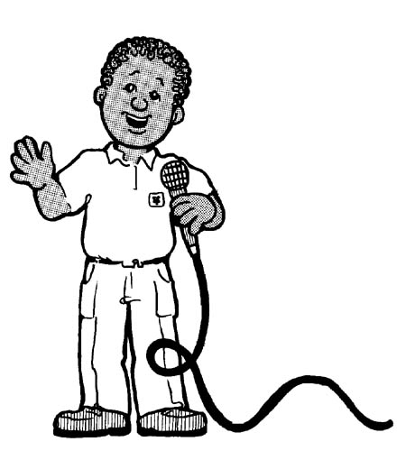
WHAT DO CLUB OFFICERS DO?

4-H Club officers are elected by members. Each officer has a specific job.

President The president leads the club meetings and keeps them orderly.
Vice President The vice president leads in the president’s absence, introduces guests, and is the program chair.
Secretary The secretary writes down what happens at the meetings, keeps attendance records, brings the secretary’s book to all meetings, and keeps track of all communications.
Treasurer The treasurer takes care of the club money, pays bills, keeps an accurate account of the club’s finances, and reports at each club meeting.
Reporter The reporter sends news stories to local newspapers and/or radio stations and plans publicity for events.
Recreation The recreation leader leads games and other fun activities
Song Leader The song leader leads the group in singing
Committee Chairs Your club may have several committees, depending on the club size and what you want to do. Committees may include: program, membership, recreation, community service, fundraising, and social events.

PROJECT WORK

As a 4-H member, youth choose at least one project. Choose a project that fits into your family, community, and the way you live. Projects provide the basis of the 4-H program by offering various education experiences. Carrying out a project will help the member “learn by doing” as well as learning why things happen the way they do. Projects are real-life experiences that help 4-H’ers learn to make sound decisions. There are more than 35 different projects. Many of the projects have been planned with several levels, so that a member may advance skills and learning opportunities.

4-H competitive events and fairs are often used to provide youth opportunities to have their project work judged against a set of standards. The evaluation of an exhibit should be a positive and motivating part of the total 4-H experience. To plan, practice, and present a finished product is to “learn by doing.” The exhibit is not an end in itself, nor does it illustrate all of the learning that has taken place during the 4-H year.

DANISH SYSTEM

The Danish system of judging is a method of evaluation where a 4-H exhibit or process is evaluated against a set of standards, and recognition is awarded on the degree to which the standard has been met by each 4-H member. The standards of excellence are often printed on a judge’s scorecard, and allows for the 4-H exhibit to be judged on one’s own merit, and not in comparison with others in the class. The following ribbons apply:

WHITE: Fair, denotes much improvement needed. Fails to meet minimum standards.
RED: Good, some improvements needed. Meets minimum standards.
BLUE: Excellent, minor improvements needed. Exceeds minimum standards.
PURPLE: Superior, outstanding on all standards.

Remember that when you exhibit at the county fair, you are asking for the judge’s opinion. The judge’s opinion is just that: an opinion, and it can vary from judge to judge and day to day. It is an opportunity to explain what you have learned, and it is an opportunity to learn from an expert. Each project is a success, no matter what color the ribbon may be!


CAMPS

Many 4-H members attend camps. They take part in educational and recreational experiences as they learn about nature and living with other people. Most importantly, 4-H’ers have fun at camp!

- 4-H Camps: For youth who have completed 3rd grade through 8th grade, and is held at the Rock Springs 4-H Camp Center, south of Junction City, KS. Older teens are also given the chance to serve as counselors to the younger campers. Activities include: hiking, fishing, campfires, flag ceremonies, swimming, crafts, recreation, and more!
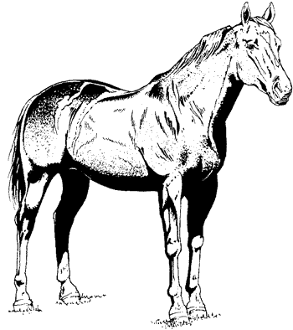
- Discovery Days: For older teens, this leadership conference is a chance to experience college life on the campus of Kansas State University. A wide range of classes are offered, from swing dancing to leadership. Plenty of chances to meet teens from across the state are available at the tailgating party, dance, and ice cream social.
- General Camps: There are many other camping opportunities available to 4-H members. Photography camps, horse camps, space camps, outdoor adventures, and day camps, just to name a few. Ask your community club leader or Extension Agent if interested in other camping opportunities.

RECORD KEEPING

You will be encouraged to keep a record and a story for each area of project work. Keeping records helps you keep track of what you are learning and helps you develop business sense. Completed records must be signed by your parents and leader at the end of the 4-H year.

A good record will reflect accomplishments and therefore serve as the basis for awards, trips, and other forms of recognition. A good record will teach a desirable habit! Modern day society demands that each and every one, no matter what vocation, keep track of financial and business matters.

Members are encouraged to work on records throughout the year as they complete project work. Many project leaders will have 4-H’ers work on their records at the project meetings. Records should include all activities regarding the 4-H’er and their project(s) throughout the year.
There are three different types of record forms which are combined to create a complete 4-H Record Book.
- Personal Page: contains space for a picture of the member, listing of projects carried, and the 4-H story. A new personal page is issued each year.
- Permanent Record: a summary of all projects, exhibits made, office held, events attended, and other participation for the entire year is made on the permanent record. Only one permanent record is necessary for all the years that a youth is a 4-H member.
- KAP (Kansas Award Portfolio): are used for each project a 4-H’er is enrolled in. The KAP form provides space for goal setting, knowledge and skills learned, work accomplished including expenses and receipts, leadership, photos and other information about the project. New KAP forms are issued each year for each project.

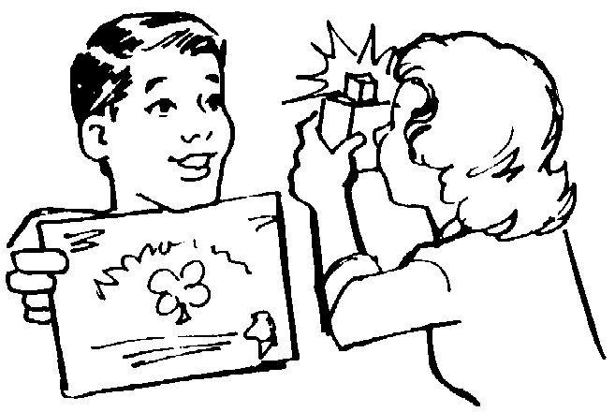
4-H members may submit completed record books to the Extension Office for champion and other awards and recognition consideration. Award applications need to be submitted along with the record book. 4-H’ers who complete their record books are invited to attend their 4-H Achievement Banquet held each year in the fall. Presentations of various awards and achievements are made at this annual event.

Note: There are units in Kansas that do not have an annual banquet for award recognition. Please contact your local extension office for more information.

Other forms of recognition are:
Achievement Pins These are awarded to 4-H’ers who meet the requirements on the pin application form and turn in a completed record book. Nine pins are awarded in a series beginning with Membership, Bronze, Clover, Emerald, Silver, Silver Guard, Leadership, Gold and Gold Guard. Applications are available in the Extension Office, as well as on the web:
http://www.kansas4-h.org/p.aspx?tabid=477

Tenure Pins The tenure award pin may be received at the completion of each 4-H year. To receive the tenure award, 4-H members must complete their 4-H record book and submit it for judging.
Project Award Pins Members must complete their 4-H record book and a Project Award Nomination Form to be eligible for a project award pin. Champions are awarded to the top 4-H’ers record book in their respective project. Winners in various projects are eligible to possibly compete at the area and state levels (some age restrictions apply).
Key Award The 4-H Key Award recognizes 4-H members who have an “all around” good 4-H record of accomplishments. To apply,
4-H’ers must have passed their 16th birthday by December 31, completed 4 or more years and meet nine other requirements. A special nomination form is required.

The greatest and most lasting rewards a 4-H member can receive are:
- Satisfaction from a job well done
- Pride in his or her accomplishments
- Recognition from leaders, parents, and other 4-H members
- Knowledge and skill gained through the project

WHY SHOULD A 4-H’ER SAY THANK YOU???

4-H’ers who receive recognition should look upon it as both a badge of honor for work well done and a symbol representing the broad interest friends of 4-H have in the program. Say “thank you” to your friends of 4-H, i.e. trophy donors, livestock buyers, project and club leaders, parents, judges, etc. A personal letter is the most satisfying and lasting way to say “thanks.”

A well written thank you letter is often read by several executives. Many donors keep letters of appreciation. Write as soon as possible! Remember, it’s not WHAT you say, but HOW you say it that counts. Your letter need not be long, but it should be sincere. Never underestimate the power of a thank you letter! Remember how it feels when someone says “thanks” to you or remember how you feel when someone doesn’t.

PARENTS, HOW CAN YOU BEST HELP YOUR 4-H’ER?

You may help boys and girls get more from their 4-H experience in several ways:
- Counsel your 4-H'er in the selection of a suitable project. Show interest. Help guide, but don't do it for them. When something is started, see that it is completed.
- Encourage your child to attend meetings regularly and attend with him/her so you'll be able to help the child know about and remember upcoming activities.
- Offer your home occasionally for a club or project meeting.
- Share your knowledge, special skills and hobbies with club members as a club leader or project leader.
- Keep informed of 4-H information that comes to members of your family.

AS EACH 4-H YEAR BEGINS, REMEMBER…

- 4-H youth are more important than the project exhibit itself.
- Learning how to do a project is more important than the project itself.
- To “learn by doing” through a useful work project is fundamental in any sound educational program, and is characteristic of the 4-H program.
- Generally speaking, there is more than one good way of doing most things.
- Our job is to teach 4-H members how to think, not what to think.
- Winning isn’t always measured by the results of the ribbon or judging event, but by the character of the 4-H’er, parent, and leader.

FOR MORE INFORMATION, PLEASE CONTACT:
K-State 4-H Youth Development Office
201 Umberger Hall
Kansas State University
Manhattan, KS 66506
Telephone: (785) 532-5800
Fax: (785) 532-5981
Kansas 4-H Website: www.Kansas4-H.org

FOR INFORMATION IN SPANISH, PLEASE CONTACT:
Rosa Gonzalez
Telephone: (620) 290-1622
E-mail: rgonzalez@ksu.edu

4-H is a community of young people across America learning leadership, citizenship and life skills.


We would like to acknowledge Ford County 4-H for the information in the original document.
K-State Research and Extension is an equal opportunity provider and employer.
Edition 2: 08/03/2015

