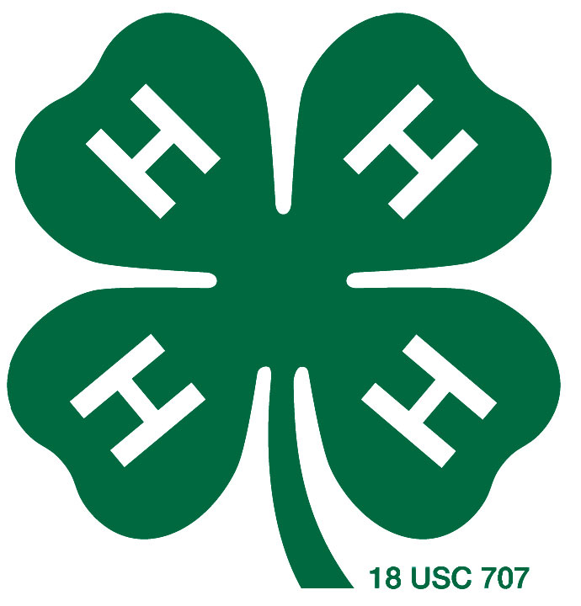
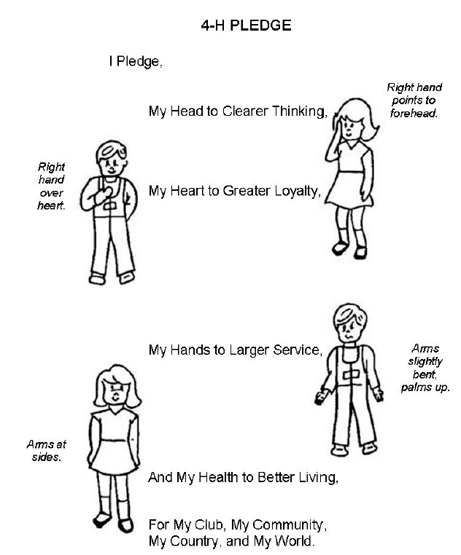

Membership
4-H membership in Kansas is open to all youth when they reach 7 years of age. 4-H members must not have turned 19 years old prior to January 1 of the current year. Members live in cities, small towns, in the country and on farms. 4-H is open to all youth regardless of race, color, national origin, sex or disability. Youth ages five and six are eligible to participate in a program called Cloverbuds. There is a $15.00 fee to join, contact the Extension Office during enrollment for more information.

These clubs also focus on one area. Typically, SPIN Clubs meet for a short period of time, not year-round.

4-H SPIN Clubs
These clubs or meetings focus on one area. Some projects have a leader, and some do not. Kids are still encouraged to enroll into a project, even if there is not a specified leader.

4-H Project Clubs
A 4-H club is a group of young people and adults who meet regularly throughout the year for fun and learning. Most clubs hold monthly meetings which are planned and led by youth officers with the guidance of the club leaders.

4-H Community Clubs

What are 4-H club meetings?
4-H Club meetings are typically held once a month. 4-H members are expected to attend their club’s meetings, and parents are strongly encouraged to attend as well. Meetings include business, educational programs and recreation. 4-H members are given the opportunity to learn to talk in front of a group and practice decision making skills.
Each 4-H club normally elects officers at the beginning of the 4-H year (October). These club officers are responsible for leading meetings, making sure all 4-H members have the opportunity to speak, and helping plan and carry out club activities.

Welcome to 4-H!
Did you know that 4-H members and leaders live all over Kansas, in all 50 United States, and in 82 other countries around the world? 4-H members are 7-19 years old, and live in cities, towns, and farms. There are over 22,000 4-H members in community clubs across Kansas!
Welcome to this wonderful organization! We realize that at times, 4-H can be confusing to understand. Hopefully this guide will help you with some of those issues. We are always here to help you with any questions.

Seward County 4-H Family Guide

The 4-H Year

4-H Age for Events
A new 4-H year starts October 1 each year and ends September 30 of the following year; however, we allow new youth to join 4-H at any time of the year.

Some events do require age limits, in this instance 4-H age is determined by the age of the participant on January 1 of that current 4-H year.
Some ages are broke by Junior, Intermediate and Senior.
Those ages are:
Junior: 7-9
Intermediate: 10-13
Senior: 14-18

The Motto
“To make the best better!”

The Pledge
I pledge:
My head to clearer thinking,
My heart to greater loyalty,
My hands to larger service, and
My health to better living for my club,
My community, my country, and my world.

The Emblem
The 4-H emblem is a four-leaf clover; the letter “H” stands for Head, Heart, Hands and Health.

The 4-H colors are green and white. Green symbolizes nature’s most common color and represents life, spring-time, and youth. White symbolizes purity.

The Colors

4-H Basics

4-H Online
- www.4honline.com
- Complete the General Information section of enrollment
- Complete the Health Form section
  - This information is taken to all 4-H events your child attends and is handled by club leader or Extension Agent only. The information is only used in the case of an emergency.
- Choose which club you will be a part of.
  - Wide Awake
  - Ornery Otters
  - One of the SPIN Clubs (Ex: Shooting Sports or Robotics)
- Choose your projects.
  - You have from October 1-May 1 to finalize your activities, after May 1 the website halts all project changes or enrollments.

Beef
Citizenship
Clothing and Textiles
Communications
Dog Care & Training
Electric
Entomology
Environmental Science
Exploring 4-H
Family Studies
Fiber Arts
Food and Nutrition
Forestry
Geology
Goats
Health and Wellness
Home Environment
Horse
Leadership
Performing Arts
Pets
Photography
Plant Science
Poultry
Rabbits
Reading
Self-Determined
Sheep
Shooting Sports
SpaceTech
Small Engines
Space Tech
Swine
Visual Arts
Wildlife
Woodworking

Selecting a project is an exciting part of 4-H! Below is a partial list of the projects 4-H has to offer:
In choosing a project, the 4-H’er will consult with their parents and 4-H leaders. The 4-H’er should base their project selection on:
  - Their own personal interests, needs and capabilities. Be sure the project is within the age and ability of the member.
  - Suitability of the area in which they live.
  - The amount of time needed to complete the project. The member and parents should be aware of the amount of time a member has to work on the project, and how much time the project requires.
  - The cost and needs of a project. The member and parents must consider how much a project will cost. Is there enough space for the project, or is additional equipment required?
  - Are project leaders available to help with the project in the club, or are the parents willing to help the member with the project?
    - If there is not a project leader for a project that you are interested in, you can still sign up. The Extension Office can assist you with finding information and tools you will need to complete the project.

How do I select projects?
Other than age, the only 4-H requirement for membership is that youth enroll in at least one project (learning opportunity). This is a way for members to learn life skills, explore an area of interest, and learn about possible career fields. All project selection (and/or changes) must take place by May 1 to be eligible to exhibit in the county fair.

4-H Projects

One of the true 4-H learning experiences is record keeping. Records are the way 4-H members keep track of what they did in their 4-H projects during the year, October through September. This does take time, but the 4-H’er actually learns important skills that will benefit them in the future. Records will be turned in September and judged.

All of the record book pages are found at
www.seward.ksu.edu/4-h/forms

The records that we typically use in Seward County are not the state record books. This means that they can be judged on a county level, but NOT on a state level. If a 4-H’er would like to compete on state level, they need to contact the Extension Office.

Record Keeping
If a 4-H’er submits a record book the last three years of high school, they are eligible for a $1000 scholarship!

- Write something down as it occurs, rather than recall all the activity dates and information later

- Records should include all activities regarding the member that occur during the 4-H year (October 1 to September 30)

- The record is a tool to be used when applying for awards

- Green 4-H Covers can be picked up at the Extension Office

- Use tabs in your book

- The Extension Agents are happy to help with your books - Look for trainings or ask for a one-on-one session
All necessary forms for record keeping can be found at www.seward.ksu.edu/4-h/forms

Record Keeping Tips
- Personal Page - Completed yearly, the 4-H member will write basic information about themselves for the current year. There is also space for a current picture of the 4-H member.
- Permanent Record - In these four sections, members can list project experiences, offices held, committee work, school activities and community activities. The member adds on information to this document each year.

- Project Records - Each 4-H’er is encouraged to keep records of their projects. Members must choose the correct record to use. There are different records for general or livestock, and each age division.
- 4-H Story - The 4-H’ers story conveys how their total 4-H year impacted them and their family. This story should include an introduction, the major project information, project leadership, and citizenship and information about the 4-H’ers personal satisfaction and future goals.

Parts of the Record Book
4-H’ers are encouraged to give a presentation at a project meeting, club meeting, county or regional club days and fair. The Extension Office has a complete guide to presentations pertaining to Club Days.

Project Talk
This is a talk that tells. The member tells what he/she is doing in a project, where he/she went, what was seen, what activities were conducted, etc.

Demonstration
Showing and telling how to do something, and there is a finished product.

Illustrated Talk
Uses visuals such as slides, pictures, charts or models to explain what is being said.

Public Speaking
This is a presentation about a topic delivered without the use of visuals or demonstration. The presentation is typically given by older members.

Reading
A short excerpt from a poem or short story.

Music/Dance or Other Talent
4-H’ers can showcase their talents.

Skit
This can be a combination of a few 4-H’ers or the whole club.

4-H Presentations
Achievement Pins – members are asked to complete certain steps to receive a pin for their year in 4-H

**Outstanding 4-H’er – a group of adult advisors choose an outstanding 4-H’er in each age division each year. They look at your overall involvement in 4-H.

**Trip Awards – Each year, three 4-H’ers in each age division are awarded with a trip.

**Both of these awards are judged from the Trip and Award Application

All forms can be found at www.seward.ksu.edu/4-h/forms

All forms will be due in September, along with the record book

.

Awards
The object of awards in 4-H is to recognize 4-H’ers for their accomplishments and to help them learn the process of goal setting and evaluation.

Awards – 4-H rewards for a job well done!

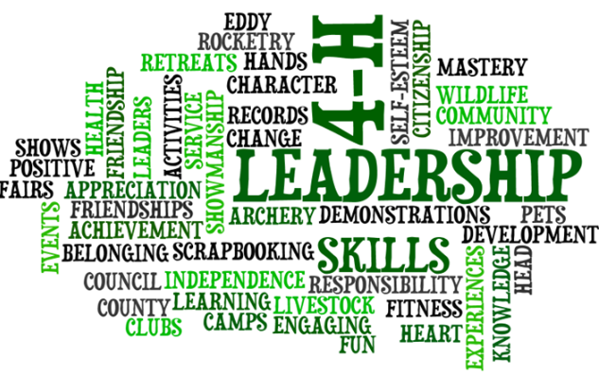

4-H Events

Heart of Kansas Camp
A four day, three night experience at Rock Springs Ranch, located outside of Junction City, for 4-H’ers 3rd – 8th grade. The camp is a fun-filled time of horseback riding, fishing, swimming, crafts, leadership games and much more!

Wildhorse Camp
This is a three day, two night camp held at Scott Lake near Scott City. This camp is for youth ages 7-13. Kids will get a complete camp experience by swimming, hiking, crafts and other group activities.

Discovery Days
Held at Kansas State University. Members, leaders and parents may attend. Classes and learning activities are the focus of this mini-college event. Youth must have completed their freshmen year of high school before attending.

County/Regional 4-H Club Day
A county event that provides 4-H members the opportunity to develop public appearance skills. The presentation is evaluated by a judge and presented a purple, blue, red, or white ribbon. The top contestants in each category will advance on to Regional 4-H Days. (See more information under 4-H Presentations) Regional Club Day is a partnership between Johnson, Grant, Morton, Stevens, Haskell and Seward Counties. It will rotate to one of those locations each year.

Achievement Celebration
This fall event is to honor 4-H members and leaders. Various awards are given out. Everyone involved in 4-H is encouraged to attend.

Seward County Five State Fair
This annual August event is where 4-H’ers exhibit an end product of their current 4-H projects for evaluation. Seward County is unique in that the Seward County Fair is simultaneous with the Five State Fair. It gives our 4-H’ers a chance to double enter their exhibits.

Kansas State Fair
4-H’ers age 9 and older who have met all requirements to enter, can compete at the State Fair. Each division has special requirements for eligibility at State Fair, based on County Fair awards. The fair is held in Hutchinson and starts the first weekend after Labor Day and runs through the following weekend.

Citizenship Washington Focus D.C.
Each summer Kansas sends delegates to the conference at the National 4-H Center outside Washington D.C. 4-H’ers age 14-19 are involved in citizenship/leadership workshops in addition to viewing the historic area. Delegates are selected by applications submitted to the state in January. 4-H Council offers some partial scholarships with the balance being paid by the 4-H’er.

Southwest Youth Leadership Forum
This is a one-day event held in the Southwest Kansas area. Youth ages 12-18 can attend this leadership workshop and listen to special speakers.

Citizens in Action
Youth ages 13-18 may attend this event at the State Capitol in Topeka. This two-day event in January shows Kansas Youth how the state legislative process works and how their voice and participation in decision making can make a difference.

National 4-H Week
The first full week in October is set aside each year to recognize and promote 4-H. Each year a theme highlights the week and is used throughout the year. 4-H clubs may have window displays, booths or special promotions of 4-H in their communities.

Campference
This event is held at Rock Springs near Junction City in June. It is focused on the “betweeners” ages 12-14. They will experience the feel of a conference while enjoying camp activities.

Kansas Youth Leadership Forum
This two day event is held at Rock Springs, located south of Junction City. It features leadership workshops, youth council elections, opportunities to learn new things, make new friends and have fun with youth from across the state. This is for youth ages 14-18.

4-H Events Cont.
RADA is kitchenware that 4-H’ers are able to sell. This is the only county organized fundraiser throughout the year. 4-H’ers will receive 40% of their sales to use towards 4-H events or their 4-H projects. A form must be filled out and submitted by the 1st of the month in order for kids to receive their money by the 15th of the month.

.

RADA

Fundraisers and Event Scholarship

Get involved
in 4-H!
4-H activities are fun, hands-on, rewarding, and will make you want to get involved more!

To ensure the best possible experience through 4-H, you will need to put a little effort into it. Here are some things you can do to make sure you are getting the most out of your experience:

- Attend all of your club meetings if possible. Arrive on time and plan to stay until the meeting ends.
- An active club member volunteers for jobs without being coaxed. GET INVOLVED!!
- Go to meetings with your ideas and share them with others. Listen to what others have to say. Even if you don’t agree with other’s opinions, it lets you hear other points of view.
- Be a friend. Get to know other club members. Help out when needed.
- Make suggestions and present ideas. This is your 4-H club so plan activities that you will have fun with as well as learn from.
- Stay updated about important dates and opportunities. It is your responsibility to make sure you turn in registration paperwork. You WON’T want to miss out on any fun!

Your Job as a 4-H Member
Each 4-H’er is eligible for up to $75 per year to use towards events. This money comes from the 4-H Council. A form must be filled out and received by the Extension Office prior to the event that the 4-H’er wishes to attend. After the event, the 4-H’er is to write a thank-you to 4-H Council for the money. At this time, they will receive their money.

Both the RADA form and the Event Scholarship can be found at
www.seward.ksu.edu/4-H/forms or picked up at the Extension Office

Check with your 4-H club for other opportunities to help fund events.

Event Scholarship
4-H parents are the most important people in a 4-H member’s life. By making 4-H a family activity, you will be able to take an active role in your child’s activities.
Here are three key points about parental 4-H involvement:
- Know what is expected of your children in 4-H
- Know what is expected of you as a parent of 4-H members
- Know that you as a parent play an active part in the 4-H club’s leadership team

Parents – Partners on the 4-H team

SHARE
- Take an interest in your child’s 4-H projects and activities.
- Learn what 4-H is about, its purpose and objectives.
- Assist your child in selecting projects they enjoy and have the ability to do

BE THERE
- Your child will gain more from 4-H by attending club meetings regularly and getting involved
- Encourage your children to participate in club activities
- Provide transportation for your child to and from club meetings and activities
- Parents can be a part of 4-H too! Attend club meetings with your child
- Get to know the club leader and project leaders
- Be willing to volunteer for club activities and tasks

PREPARE
- Parents can assist by helping a child understand the value of having projects, duties, and presentations done on time and in a proper way
- Provide encouragement and guidance in your child’s project work. Help them understand what to do – but give them the responsibility to do the actual work
- Encourage your child to make a note of 4-H experiences in the Permanent Record. Familiarize yourself with project materials so you can help as needed
- Help your child make plans for what they want to learn and how they would like to expand their project experience
- Read the 4-H Newsletter to understand the months activities

CARE
- Arrange to attend programs and events where your child is taking part
- Your presence shows that you consider your child, and what he or she is doing, to be very important

Helpful Information from 4-H Parents

“If I had only known….”

- To keep a drawer/shelf/box for ALL 4-H newsletters, mailings, and record books for easy access

- Members are to keep reusing the green Record Book covers year to year

- Parents and even grandparents are encouraged to attend and participate in 4-H events with their youth. 4-H is a FAMILY organization

- READ MY NEWSLETTER and ask questions!

Mirna Bonilla, Family and Consumer Science/4-H Agent
mbonilla@ksu.edu

Kylee Harrison, Ag and Natural Resources/4-H Agent
kharrison@ksu.edu

Chelsea Shuck, Office Professional
cshuck@ksu.edu

Office Contact Information
1081 Stadium Road
Liberal, KS 67901
620-624-5604
sw@listserv@ksu.edu

Like us on Facebook at Seward County Kansas 4-H & Extension


Meet The Staff

